Brain Tumor Detection System
Use Case Modeling

UML Use Case Diagrams and Descriptions
for Patient, Doctor, and Admin Actors

Graduation Project — 2026

Table of Contents

1. Use Case Modeling Overview
This document presents the complete UML use case modeling for the Brain Tumor Detection and Treatment Suggestion System. It includes three use case diagrams (one per actor) and detailed use case descriptions for all major system interactions.
System actors:
- Patient — Primary user who uploads MRI scans, views AI results, books consultations
- Doctor — Medical professional who reviews AI reports and provides clinical assessments
- Admin — System operator who verifies doctors and manages users
Secondary actors: Application Database, FastAPI AI Service

UML notation used:
- Solid line = association (actor interacts with use case)
- «include» dashed arrow = mandatory sub-function always invoked
- «extend» dashed arrow = conditional behavior invoked only in certain scenarios
- System boundary = dashed rectangle enclosing all use cases

2. Patient Use Case Diagram
The Patient actor has 13 use cases covering the complete patient journey: registration, authentication, health data intake, MRI upload and AI analysis, results viewing with triage classification, doctor consultation, messaging, and account management.

Use cases: Register, Login, Fill Intake Form, Upload MRI, View AI Results, View Scan History, Browse Doctors, Book Consultation, View Doctor Notes, Send Message, Share Results, Manage Profile, Rate Doctor
Include relationships: Login → Verify Credentials; Upload MRI → AI Processing; View AI Results → Display Triage; View AI Results → Show Disclaimer
Extend relationships: Login → Error Message (on invalid credentials)

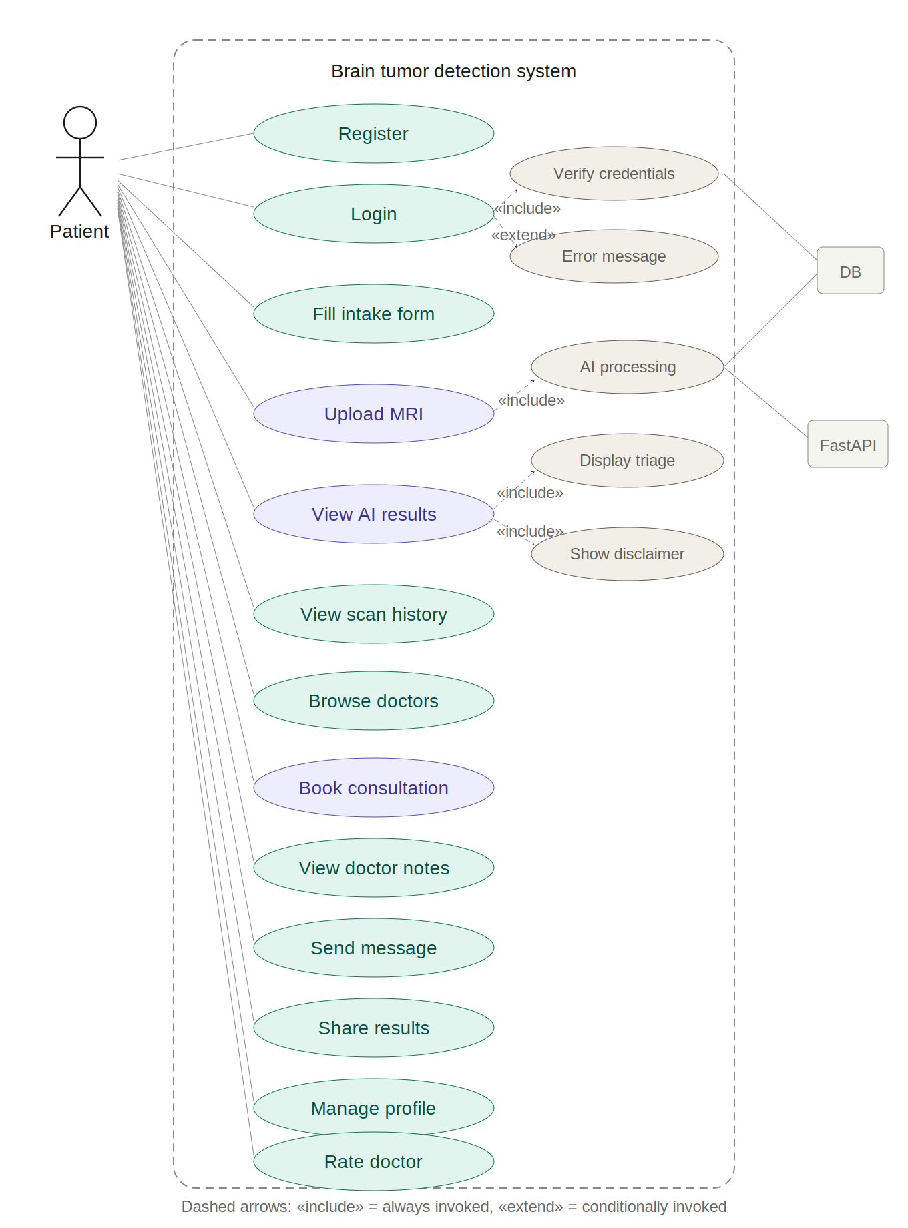
Figure 2.1 — Patient use case diagram
Figure 2.1 — Patient use case diagram

3. Doctor Use Case Diagram
The Doctor actor has 7 use cases covering the professional workflow: registration with medical license, dashboard management, AI report review, clinical note writing with AI agreement assessment, consultation handling, and patient communication.

Use cases: Register with License, Login, View Dashboard, Review AI Report, Write Clinical Notes, Accept/Decline Consultation, Send Message
Include relationships: Register with License → Upload License; Write Clinical Notes → Select AI Agreement Level

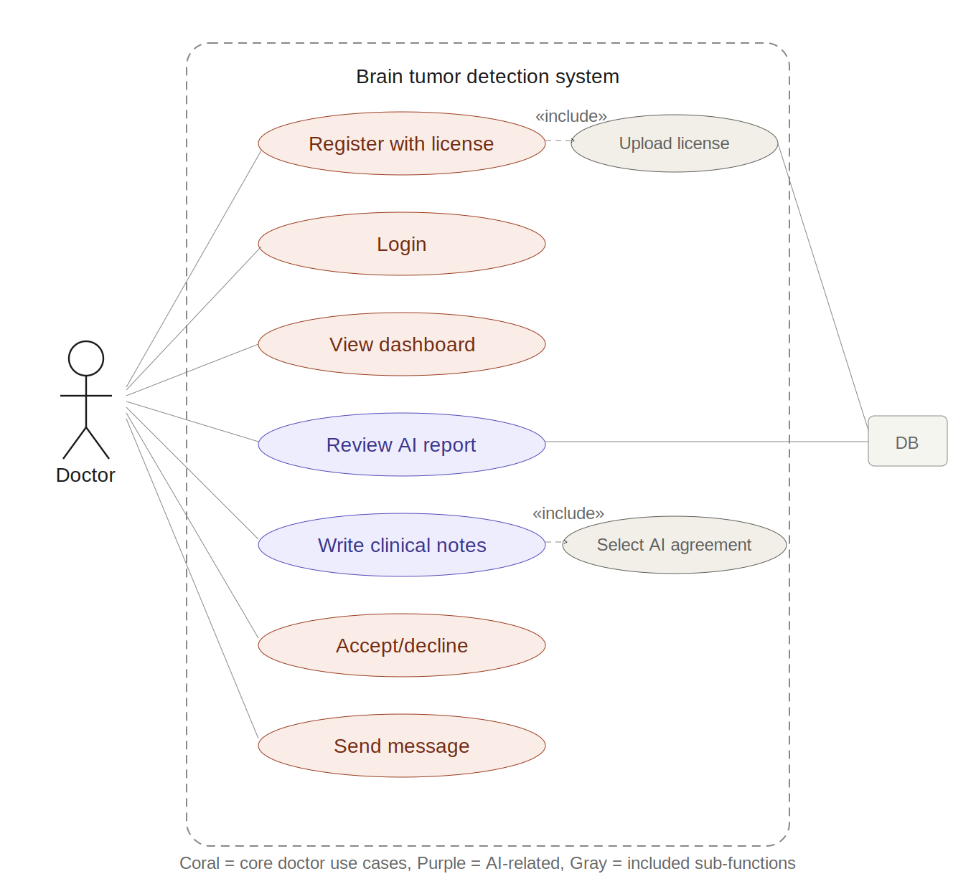
Figure 3.1 — Doctor use case diagram

4. Admin Use Case Diagram
The Admin actor has 4 use cases covering platform governance: authentication, doctor verification with license review, user management, and system statistics monitoring.

Use cases: Login, Verify Doctor, Manage Users, View Statistics
Include relationships: Verify Doctor → Review License Document

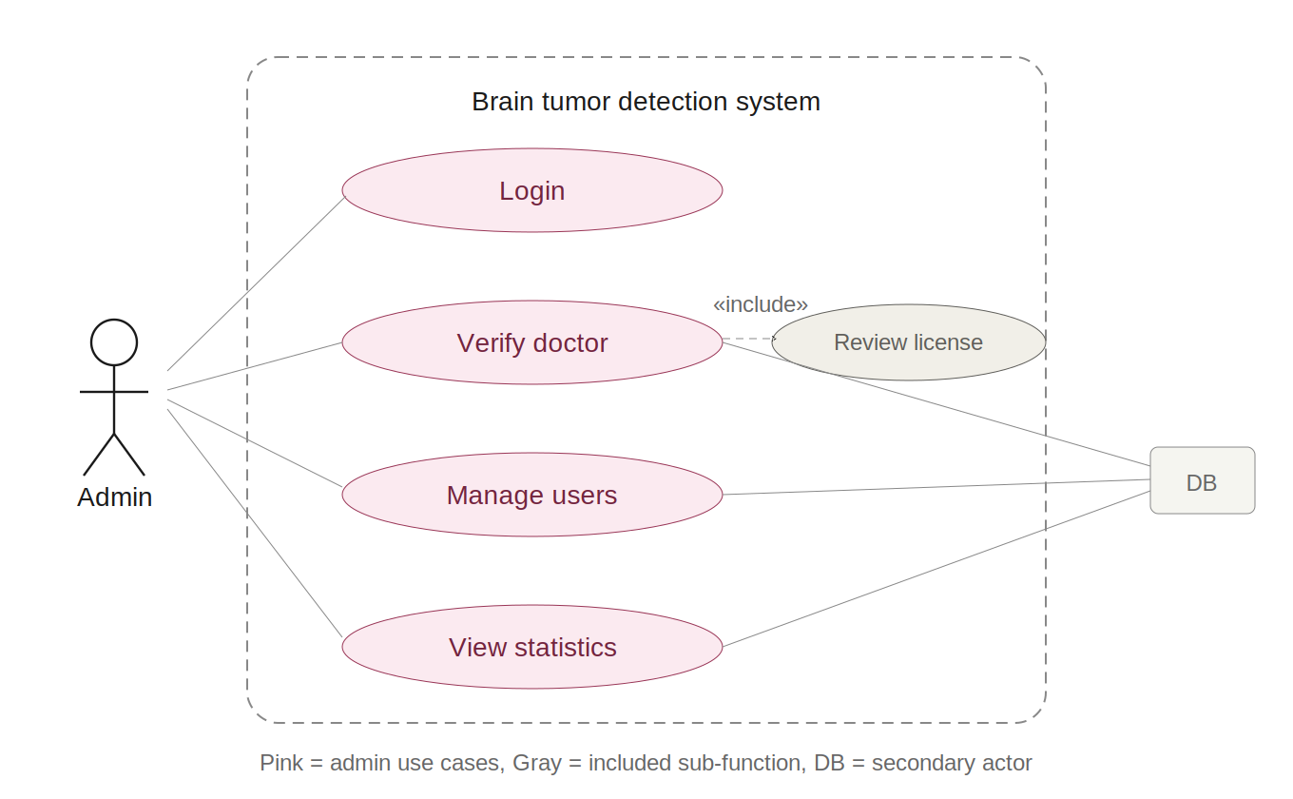
Figure 4.1 — Admin use case diagram

5. Patient Use Case Descriptions

UC-01: Register
Field | Description
Use Case | Register
Summary | A new patient creates an account. The system validates input and stores credentials securely.
Actors | Patient (Primary), Database (Secondary)
Precondition | System displays landing page with registration option.
Main Sequence | 1. Patient clicks Register. 2. Enters name, email, password. 3. System validates email format and password strength. 4. Creates account in database. 5. Redirects to login with success message.
Alternative | 3a. Email already exists → error message. 3b. Password does not meet criteria → validation error.
Post-Condition | Patient account created, can log in.

UC-02: Login
Field | Description
Use Case | Login
Summary | Patient authenticates using email/password. System verifies credentials and issues JWT tokens.
Actors | Patient (Primary), Database (Secondary)
Precondition | Patient has a registered account.
Main Sequence | 1. Enter email and password. 2. System verifies credentials against database. 3. Generates JWT access token and refresh token. 4. Redirects to patient dashboard.
Alternative | 2a. Invalid credentials → error message. 2b. Account deactivated → appropriate message.
Post-Condition | Patient authenticated with valid JWT, sees dashboard.

UC-03: Fill Intake Form
Field | Description
Use Case | Fill Intake Form
Summary | Patient completes 4-step wizard providing 14 health features for the treatment model. Progress is auto-saved.
Actors | Patient (Primary), Database (Secondary)
Precondition | Patient is logged in.
Main Sequence | 1. Navigate to New Scan. 2. Step 1: age, gender. 3. Step 2: family cancer history, previous treatment, comorbidities. 4. Step 3: headache severity, seizure history, vision problems, cognitive changes, nausea/vomiting. 5. Step 4: functional status, neurological symptoms, immunosuppressed. 6. System validates all fields. 7. Saves to database.
Alternative | 6a. Validation fails → highlight invalid fields. Progress auto-saved between steps.
Post-Condition | 14 patient features saved, patient proceeds to MRI upload.

UC-04: Upload MRI
Field | Description
Use Case | Upload MRI
Summary | Patient uploads MRI image. System processes through AI pipeline and displays loading progress.
Actors | Patient (Primary), FastAPI AI Service (Secondary), Database (Secondary)
Precondition | Intake form completed.
Main Sequence | 1. Patient drags-and-drops MRI image file. 2. System validates format (JPEG, PNG) and size. 3. Shows preview. 4. Patient confirms. 5. System sends MRI + 14 features to Node.js backend. 6. Node.js forwards to FastAPI /predict. 7. Shows loading animation (Classifying, Segmenting, Generating Treatment). 8. Receives results, saves to DB. 9. Redirects to Results page.
Alternative | 2a. Invalid format → error. 6a. FastAPI unavailable → retry option.
Post-Condition | Scan record created with AI results. Patient sees results page.

UC-05: View AI Results
Field | Description
Use Case | View AI Results
Summary | Patient views complete AI analysis: triage classification, tumor details, treatment suggestion, MRI visualization.
Actors | Patient (Primary)
Precondition | AI processing complete, results saved.
Main Sequence | 1. Display color-coded triage banner (red/amber/green). 2. Show 3-panel MRI view: original, overlay, annotated. 3. Show brain region mini-diagram. 4. Display findings: tumor type, location, size (mm²), hemisphere. 5. Show treatment suggestion with confidence score. 6. Show urgency level and triage-driven CTA. 7. Display medical disclaimer. 8. Patient can book consultation, share results, or return to dashboard.
Alternative | If triage = Emergency, CTA shows nearest hospital suggestion via geolocation.
Post-Condition | Patient has reviewed AI analysis and can take next action.

UC-06: View Scan History
Field | Description
Use Case | View Scan History
Summary | Patient browses all past scan records with summary information and links to full results.
Actors | Patient (Primary), Database (Secondary)
Precondition | Patient is logged in and has at least one completed scan.
Main Sequence | 1. Patient navigates to Dashboard. 2. System retrieves all scan records for this patient. 3. Displays list with date, tumor type, triage tier, and size for each scan. 4. Patient clicks a scan to view full results.
Alternative | 3a. No scans found → empty state with prompt to start new scan.
Post-Condition | Patient can view any past scan result in detail.

UC-07: Browse Doctors
Field | Description
Use Case | Browse Doctors
Summary | Patient searches and filters verified doctors to find a suitable specialist.
Actors | Patient (Primary), Database (Secondary)
Precondition | Patient is logged in. At least one verified doctor exists.
Main Sequence | 1. Patient navigates to Doctors page. 2. System displays list of admin-verified doctors. 3. Each card shows name, specialization, experience, average rating. 4. Patient can filter by specialization. 5. Patient selects a doctor to view full profile.
Alternative | 2a. No verified doctors → empty state message.
Post-Condition | Patient can view doctor profiles and proceed to booking.

UC-08: Book Consultation
Field | Description
Use Case | Book Consultation
Summary | Patient requests a consultation with a verified doctor after viewing AI results.
Actors | Patient (Primary), Doctor (Secondary), Database (Secondary)
Precondition | Results viewed. Verified doctors exist.
Main Sequence | 1. Click Book Consultation CTA. 2. Browse doctor list with specialization and ratings. 3. Select a doctor. 4. System sends consultation request. 5. Show pending status on dashboard.
Alternative | 2a. No doctors available → empty state. 4a. Doctor may decline → patient notified, can choose another.
Post-Condition | Consultation request created with pending status.

UC-09: View Doctor Notes
Field | Description
Use Case | View Doctor Notes
Summary | Patient views the clinical assessment provided by the doctor after consultation.
Actors | Patient (Primary), Database (Secondary)
Precondition | Doctor has submitted clinical notes for the consultation.
Main Sequence | 1. Patient receives notification that doctor notes are available. 2. Navigates to scan record or consultation. 3. System displays doctor agreement level (agree/partial/disagree). 4. Shows doctor free-text clinical notes. 5. If doctor disagreed, shows alternative recommendation.
Alternative | 2a. Notes not yet submitted → show pending status.
Post-Condition | Patient has read the doctor clinical assessment.

UC-10: Send Message
Field | Description
Use Case | Send Message
Summary | Patient sends a message to the doctor within an active consultation context.
Actors | Patient (Primary), Doctor (Secondary), Database (Secondary)
Precondition | Consultation is in accepted or in-progress status.
Main Sequence | 1. Patient opens consultation detail page. 2. Types message in chat input. 3. System saves message to database. 4. Doctor receives notification of new message.
Alternative | 3a. If consultation is completed or declined, messaging is disabled.
Post-Condition | Message is saved and visible to both patient and doctor.

UC-11: Share Results
Field | Description
Use Case | Share Results
Summary | Patient generates a secure shareable link to their scan results for an external doctor.
Actors | Patient (Primary), Database (Secondary)
Precondition | Scan results exist.
Main Sequence | 1. Patient clicks Share Results on the results page. 2. System generates a unique share token. 3. System creates a public URL with the token. 4. Patient copies the link. 5. Anyone with the link can view the results without authentication.
Alternative | 2a. Share token already exists → display existing link.
Post-Condition | Shareable link is active and accessible.

UC-12: Manage Profile
Field | Description
Use Case | Manage Profile
Summary | Patient updates personal information, resets password, or deactivates account.
Actors | Patient (Primary), Database (Secondary)
Precondition | Patient is logged in.
Main Sequence | 1. Navigate to Profile page. 2. View current information. 3. Edit name, email, or intake form answers. 4. System validates and saves changes. 5. Alternatively, initiate password reset or account deactivation.
Alternative | 4a. Email change conflicts with existing account → error. 5a. Account deactivation requires confirmation.
Post-Condition | Profile updated or account action completed.

UC-13: Rate Doctor
Field | Description
Use Case | Rate Doctor
Summary | Patient provides a rating and optional review after a completed consultation.
Actors | Patient (Primary), Database (Secondary)
Precondition | Consultation is completed. Doctor has submitted clinical notes.
Main Sequence | 1. System prompts patient to rate after consultation completion. 2. Patient selects a star rating (1-5). 3. Patient optionally writes a text review. 4. System saves rating and updates doctor average rating.
Alternative | 2a. Patient skips rating → no action taken.
Post-Condition | Rating saved. Doctor average rating recalculated.

6. Doctor Use Case Descriptions

UC-14: Register with License
Field | Description
Use Case | Register with License
Summary | Doctor registers with credentials and uploads medical license for admin verification.
Actors | Doctor (Primary), Database (Secondary)
Precondition | Registration page displayed.
Main Sequence | 1. Select Doctor registration path. 2. Enter name, email, password, specialization, years of experience. 3. Upload medical license document (PDF/image). 4. System creates account with unverified status. 5. System notifies admin of pending verification.
Alternative | 3a. Upload fails → retry option. 2a. Email exists → error.
Post-Condition | Doctor account created (unverified). Admin notified.

UC-15: View Dashboard
Field | Description
Use Case | View Dashboard
Summary | Doctor views their professional dashboard with incoming requests, active patients, and appointment overview.
Actors | Doctor (Primary), Database (Secondary)
Precondition | Doctor is logged in and verified.
Main Sequence | 1. Doctor navigates to dashboard. 2. System displays incoming consultation requests with patient name and triage tier. 3. Shows active consultations in progress. 4. Shows completed consultations count and AI agreement statistics.
Alternative | 2a. No pending requests → show empty state with informational message.
Post-Condition | Doctor has overview of all professional activities.

UC-16: Review AI Report and Write Clinical Notes
Field | Description
Use Case | Review AI Report and Write Notes
Summary | Doctor reviews full AI analysis and provides clinical assessment with agreement level.
Actors | Doctor (Primary), Database (Secondary)
Precondition | Consultation accepted. AI results exist.
Main Sequence | 1. Open patient case from dashboard. 2. View AI report: tumor type, size, location, hemisphere, treatment suggestion, triage tier, confidence scores. 3. View patient intake form answers (14 features). 4. Select agreement: Agree / Partially Agree / Disagree. 5. If disagree or partial, enter alternative recommendation. 6. Write free-text clinical notes. 7. Save notes. 8. Patient is notified.
Alternative | 4a. Can save as draft before finalizing.
Post-Condition | Notes saved and visible to patient on scan record.

UC-17: Accept/Decline Consultation
Field | Description
Use Case | Accept/Decline Consultation
Summary | Doctor manages incoming consultation requests from patients.
Actors | Doctor (Primary), Database (Secondary)
Precondition | At least one pending consultation request exists.
Main Sequence | 1. Doctor views pending requests on dashboard. 2. Selects a request to view patient summary and triage tier. 3. Clicks Accept or Decline. 4. System updates consultation status. 5. Patient is notified of the decision.
Alternative | 3a. If declined, patient can request a different doctor.
Post-Condition | Consultation status updated. Patient notified.

7. Admin Use Case Descriptions

UC-18: Verify Doctor Registration
Field | Description
Use Case | Verify Doctor Registration
Summary | Admin reviews pending doctor registration, examines uploaded license, approves or rejects.
Actors | Admin (Primary), Database (Secondary)
Precondition | Pending doctor registrations exist.
Main Sequence | 1. Open verification queue. 2. View list of pending registrations. 3. Select a registration. 4. Review doctor details and uploaded license document. 5. Click Approve or Reject. 6. System updates doctor status in database. 7. Doctor is notified of decision.
Alternative | 5a. If rejected, admin provides a reason sent to doctor.
Post-Condition | Doctor status updated to verified or rejected.

UC-19: Manage Users
Field | Description
Use Case | Manage Users
Summary | Admin searches, views, and manages all platform user accounts.
Actors | Admin (Primary), Database (Secondary)
Precondition | Admin is logged in.
Main Sequence | 1. Navigate to User Management page. 2. Search users by name, email, or role. 3. View user profile details. 4. Optionally disable or re-enable an account.
Alternative | 4a. Cannot disable other admin accounts.
Post-Condition | User account status updated as needed.

UC-20: View Statistics
Field | Description
Use Case | View System Statistics
Summary | Admin views platform-wide statistics and system health metrics.
Actors | Admin (Primary), Database (Secondary)
Precondition | Admin is logged in.
Main Sequence | 1. Navigate to Statistics page. 2. System displays total scans processed. 3. Shows active doctors count and verification rate. 4. Shows most common tumor types distribution. 5. Shows consultations per month trend. 6. Shows AI-doctor agreement rate (if available).
Alternative | No alternative flows — read-only view.
Post-Condition | Admin has reviewed system health metrics.

